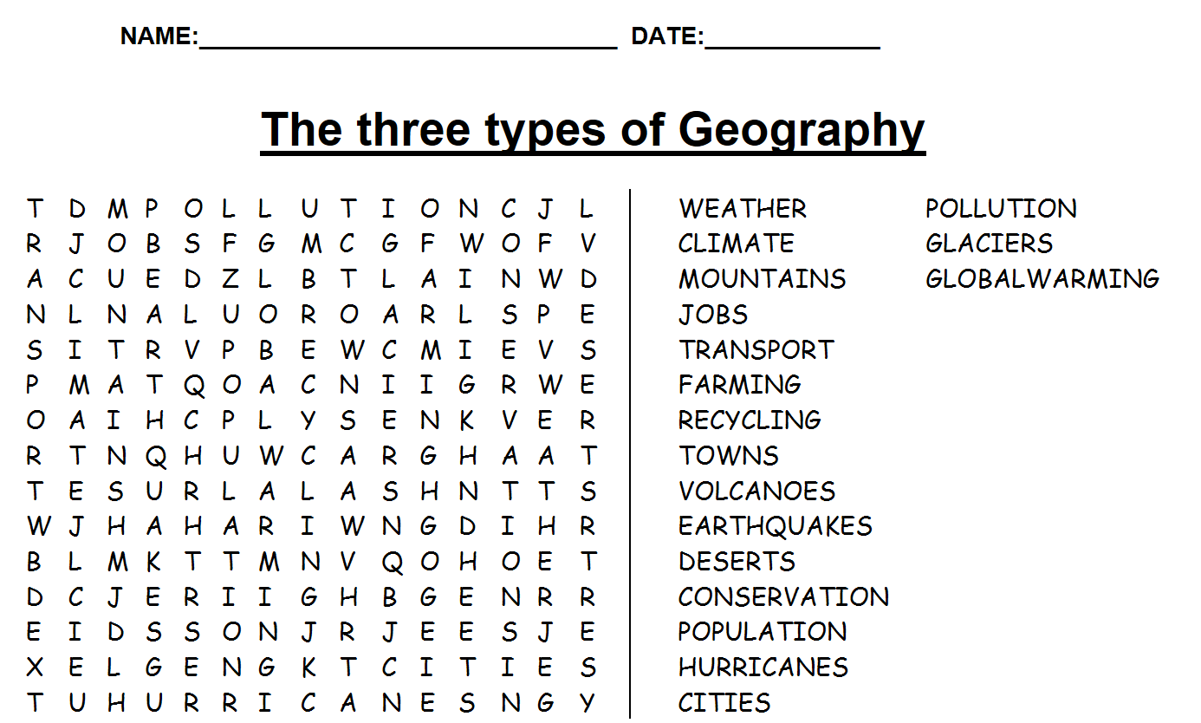
Physical Geography | Human Geography | Environmental Geography

