Name:
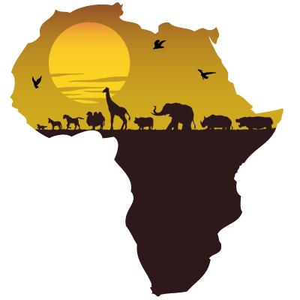Africa, a diverse continent
What I know now | What I find out during the lesson | What I would like to know in the future

